**DS3-Grey Campus Assignment 1**

**Name: Krithika Jagannath Date: 22 March 2021**

1**.** What is the basic difference and similarity between a vector and a matrix?

Ans:

Difference:

Vector is a basic data structure that contains element of similar type like logical, integer, double, character, complex or raw. Whereas a matrix is a two dimensional data structures. The dimension vector is itself an integer vector of length 2.

So, vector is single dimensional and matrix is multi-dimensional.

Similarity:

 A **vector** and a **matrix** are both represented by a letter with a **vector** typed in boldface with an arrow above it to distinguish it from real numbers while a **matrix** is typed in an upper-case letter. So, both vector and matrix have same data types.

2.What is the basic difference and similarity between a data frame and a matrix?

Ans:

Difference:

**In a data frame** the columns contain different types of **data**, but **in a matrix** all the elements are the same type of **data**. A **matrix in** R is like a mathematical **matrix**, containing all the same type of thing (usually numbers).

Similarity:

Both are multi dimensional and both are used to organize data, so we can use it effectively.

3. Create a vector using (15, TRUE, “World”). What happened to your result?

Ans:

The given data is not of the same data type but for a vector it is necessary that we have the same data type so this will be converted to characters if we execute it as shown below.

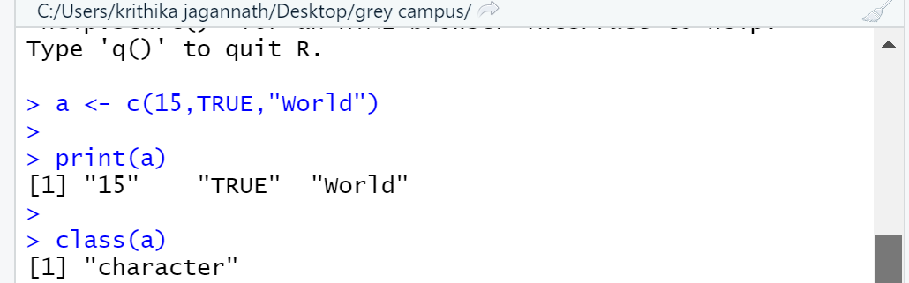

4. John’s scores in the final semester for the three subjects are 95, 91, and 88. The subjects are Statistics, Linear Algebra, and Calculus. Using these create a vector and give names to all elements of the vector based on their subjects.

Ans:

The steps for this is as follows:

1. Create a vector
2. Assign the subject names
3. Print the output

Following is the code for the same:

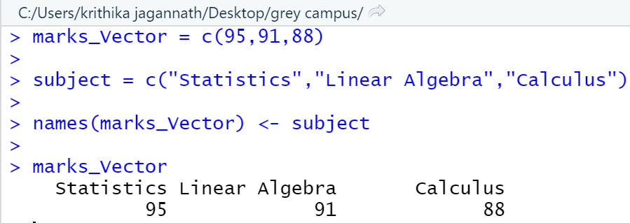

5. Please check the types (character or numeric) of the vector you created.

Ans:

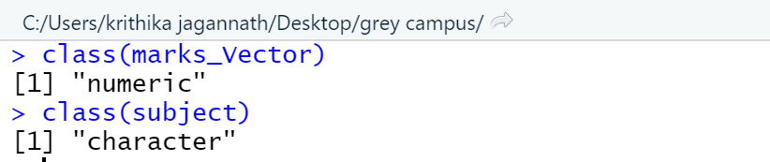

6. You have three students in your class (choose any name you want). You must create a matrix using their score in the above-mentioned subjects (question 4) Student 1 (95, 91, and 88), Student 2(96, 94, and 97), Student 3(88, 98, and 85). Create a matrix and label column and row names

Ans: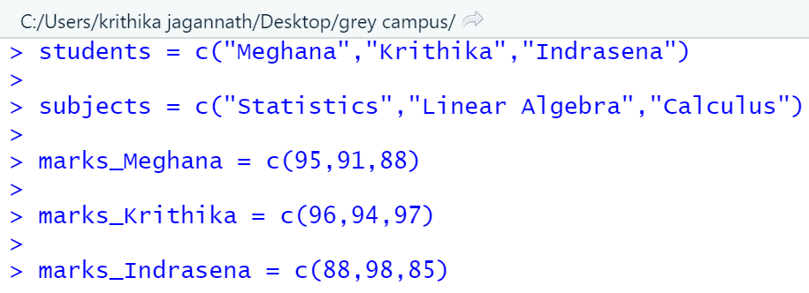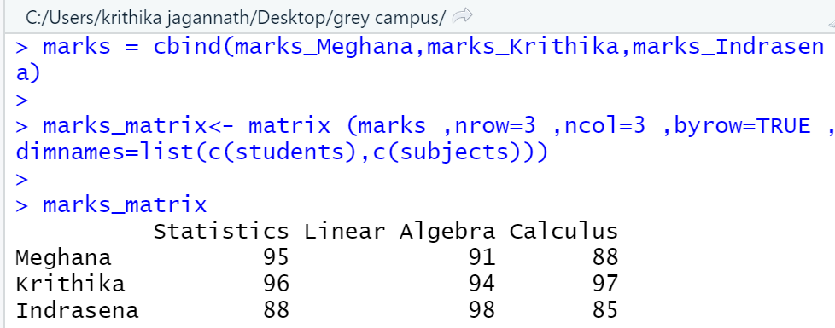

7. Convert the created matrix into a data frame.

Ans:

We can use the data.frame() function as shown below

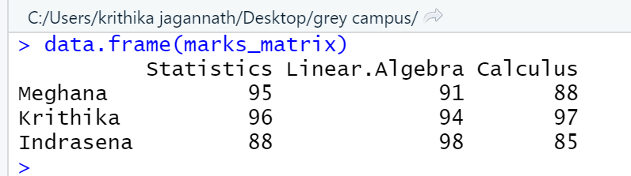

8. Create three vectors using five countries (your choice) from the following website. The first vector should be country names, the second vector should be the total number of cases, and he third vector should contain the total <https://www.worldometers.info/coronavirus/>

Ans:

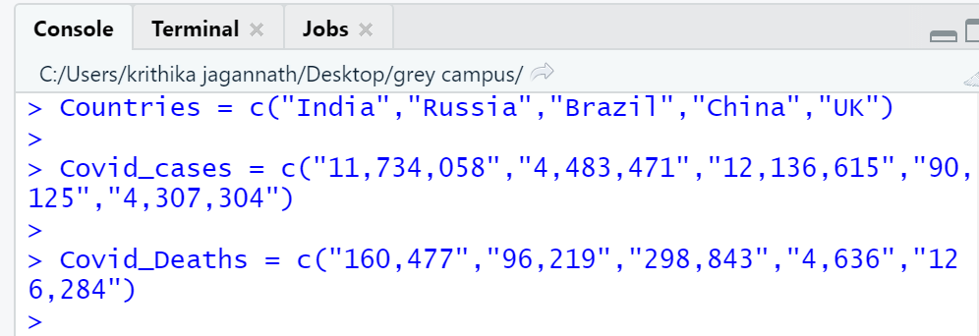

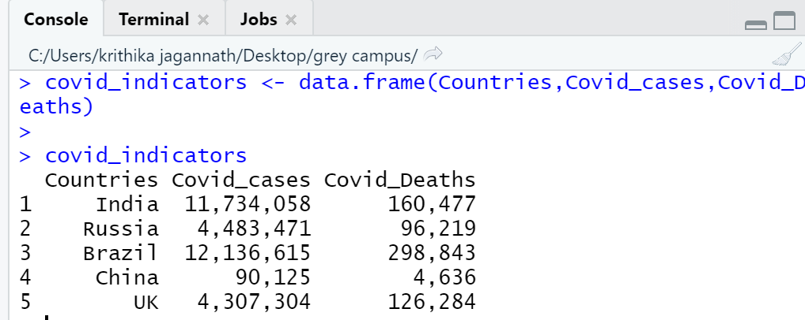

9. Please read the mtcars data set from R. It is a built-in data set. Please check the structure of the data set. If required, please convert the data into their appropriate data types (character, logical, factor, etc). Save your results as a new data frame using a new name.

Ans: